MINISTRY OF EDUCATION AND SCIENCE OF UKRAINE

NATIONAL TECHNICAL UNIVERSITY

«KHARKIV POLYTECHNIC INSTITUTE»

Department of Software Engineering and Management Information Technologies

Report from lab № 1

discipline «Fundamentals of python»

Kharkiv

2019

**Laboratory work №1**

*Use:*

input(),

output(),

/ (division),

+ (sum),

– (subtraction),

// (quotient from division entirely),

* (multiplication),

** (exponentiation),

% (remainder of the division completely),

#(comments)

*1. Sum of three numbers*

Write a program that reads three numbers and displays their sum. Each number is written on a separate line.

*2. Area of right triangle*

Write a program that reads the lengths of two legs in a right triangle and displays its area. Each number is written on a separate line.

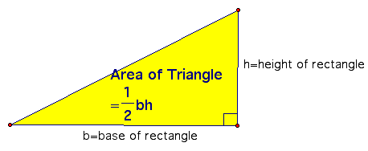

*3. Apples division*

n schoolchildren divide k apples equally, the non-fissile residue remains in the basket. How many apples will each student get? How many apples are left in the basket? The program receives the numbers n and k as input and must output the required number of apples (two numbers).

*4. Electronic clock*

Given the number n. Since the beginning of the day n minutes have passed. Determine how many hours and minutes the electronic clock will show at this moment. The program should print two numbers: the number of hours (from 0 to 23) and the number of minutes (from 0 to 59). Note that the number n may be greater than the number of minutes in a day.

*5. "Hello, Harry!"*

Write a program that greets the user by displaying the word Hello, the entered name and punctuation marks like in the example: “Hello, Harry!”

*6.* *"Next and Previous"*

Write a program that reads an integer and prints text similar to the example (spaces are important!).

|  |  |
| --- | --- |
| 1534 | The next number for the number 1534 is 1535.  The previous number for the number 1534 is 1533. |

*7. The school desk*

The school decided to type three new math classes. Since they took math classes at the same time, it was decided to set aside an office for each class and buy new desks in them. At each desk can sit no more than two students. The number of students in each of the three classes is known. How much do you need to buy school desks so that they are enough for all students? The program receives three positive integers: the number of students in each of the three classes.

*8."Shoelaces"*

A shoe factory is about to start producing an elite shoe model. The holes for lacing will be arranged in two rows, the distance between the rows is *a*, and the distance between the holes in the row is *b*. The number of holes in each row is *N*. The lacing must occur in an elite manner “up, horizontally in another row, up, horizontally, etc.” (see figure). In addition, so that the laces can be tied with an elite bow, the length of the free end of the lace should be *l*. What should be the length of the lace for these shoes?

The program receives four positive integers *a*, *b*, *l*, and *N* as an input – in that order – and should output one number – the desired length of the lace.

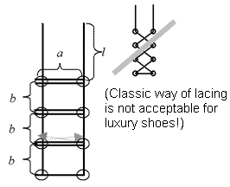

Solutions :

import sys

#no1

def add_numbers():

    num1 = input("enter number1 : \n")

    num2 = input("enter number2 : \n")

    num3 = input("enter number3 : \n")

    sum = num1 + num2 + num3

    print(" \n sum of three numbers \n")

    print(sum)

#no2

def area():

    h = float(input("enter height of triangle : \n"))

    b = float(input("enter base of triangle : \n"))

    A = 1/2 * b * h

    print("area of  triangle : \n")

    print(A)

#no3

def apples_division():

    n = int(input("enter the number school Children :"))

    k = int(input("enter the number apples :"))

    r = k % n

    share = (k - r) / n

    print("each student will get {0} apples \n", share )

    print("there are {0} apples left " , r )

#no4

def clock():

    n = int(input("enter the number of minutes passed : \n"))

    k = int(60)

    if n > 1440:

        print("time passed is more than a day ")

    else:

        mins = n % k

        hours = int((n - mins )/k)

        print("hours passed : " , hours)

        print("mintues extra passed : ", mins)

        print("\n time now is {0}:{1}" .format(hours , mins))

#no5

def hello():

    name = input("please enter your name ")

    print("\" hello {0} ! \" " .format(name))

#no6

def next_prev():

    num = int(input("please enter the number : \n"))

    next = num + 1

    prev = num -1

    print("The next number for the number  {0}  is  {1}" .format(num , next))

    print("The previous number for the number  {0}  is  {1}" .format(num , prev))

#no7

def num_desk(stud):

    if (stud % 2) > 0:

        desk = (stud / 2) + 1

        return int(desk)

    else:

        desk = stud / 2

        return int(desk)

def classes():

    class1 = int(input("enter number of students in class 1 \n"))

    class2 = int(input("enter number of students in class 2 \n"))

    class3 = int(input("enter number of students in class 3 \n"))

    print("number of desk needed for class 1 :  " , num_desk(class1))

    print("number of desk needed for class 1 :  " , num_desk(class2))

    print("number of desk needed for class 1 :  " , num_desk(class3))

#no8

def laces():

    a = int(input("please enter the distance betweeen rows \n"))

    b = int(input("please enter the distance between holes in the rows \n"))

    n = int(input("please enter the number of holes in each row \n"))

    l = int(input("please enter the lenght of extra lace needed \n"))

    #base of lace has one row

    base = a

    #three row aside from base

    rows = 3 * (a * n)

    #distance btw rows

    b = b * 3

    #total lenght

    lace = base + rows + b + l

    print(" total lenght of lace requiered is ", lace)

def main():

    add_numbers()

    area()

    apples_division()

    clock()

    hello()

if __name__ == '__main__':

    main()

No1 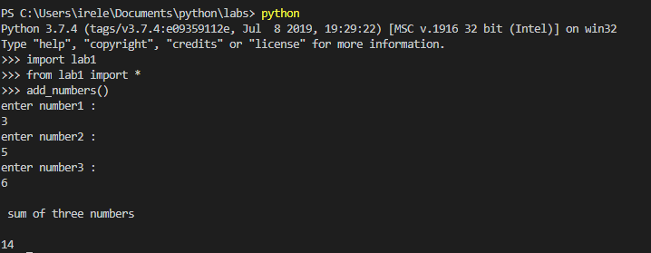

No2:

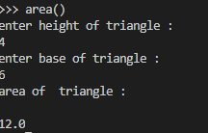

No3:

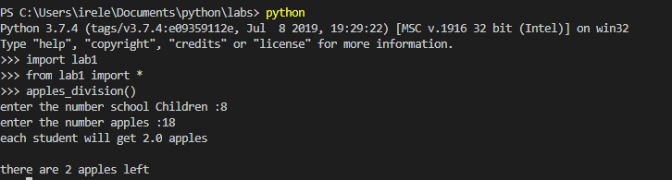

No4 :

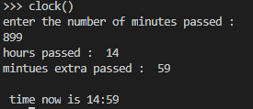

No5:



No6

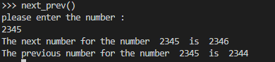

No7:

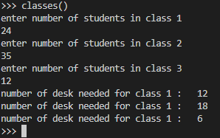

No8:

